**Online Marketing and SEO Plan**

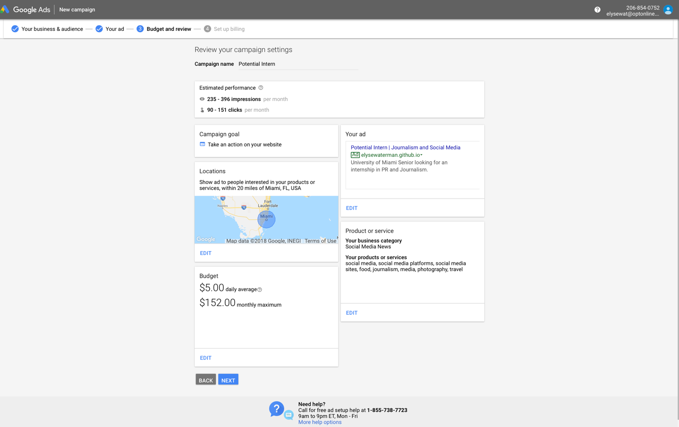When I finish this website, I am going to include the final link in my resume. However, I am also going to post it on all of my social media accounts such as Facebook, Instagram, Twitter, LinkedIn and Tumblr. On these accounts, I already follow people that have similar interests; therefor, this is a great way to promote my website and reach my target audience. Through Google Adwords, I am going buy keywords such as: social media, social media platforms, social media sites, food, journalism media, photography and travel. The duration of my campaign is one year to promote my website. It will be $5.00 per day; therefor, the total cost will be $1,825. Below you can see three screenshots of my campaign.

